|  |  |
| --- | --- |
| **Name :-** | Aryan Dilipbhai Langhanoja |
| **Enroll No: -** | 92200133030 |

## Universal NOR gate and its application in automobile alarm system

* **Aim** :-

To build automobile alarm application using basic logic gates on a generalized simulator canvas and verify its truth table.

* 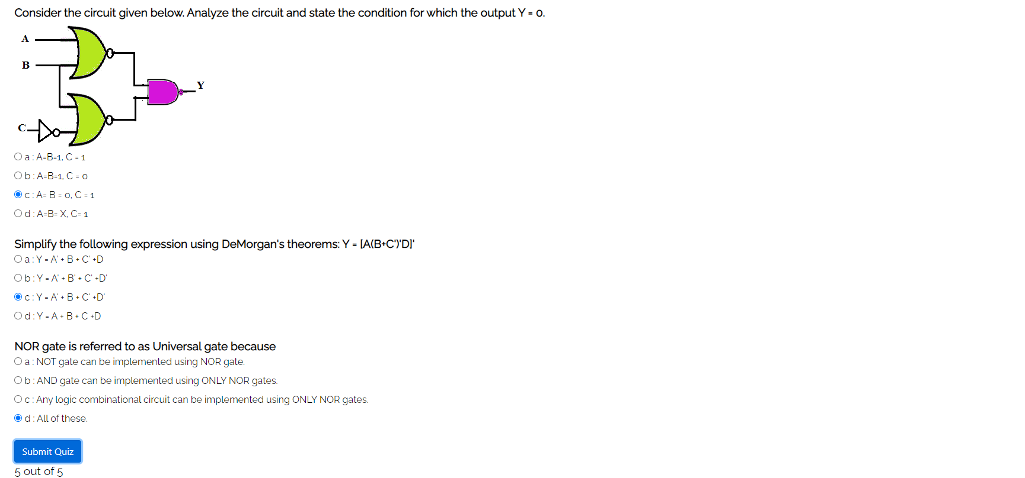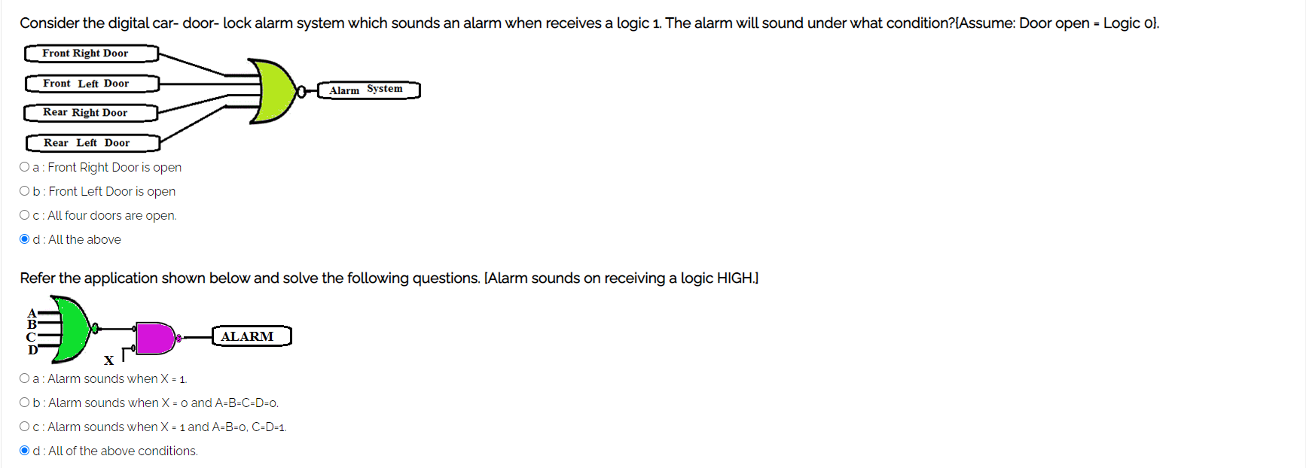**Pre-test**
* **Simulation :-**

**Task:-** Construct and verify AND gate logic using only NOR gates.

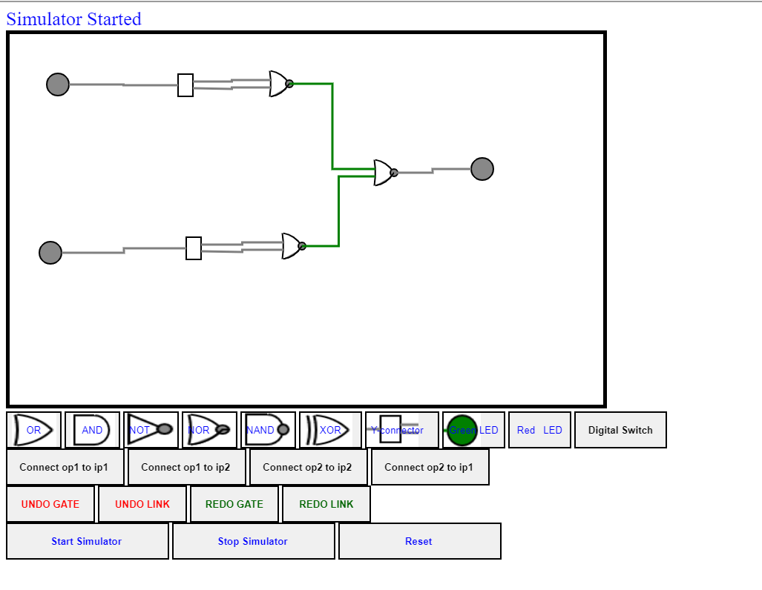

* **Post-test :-**

